Capstone Project
Project Name: Campus Energy-Use Dashboard
Course: Programming for Problem Solving using Python
Submitted By: Daksh Gautam
Roll no : 2501730352
Course title : BTECH CSE AI&ML “C”

Real-World Problem (In My Words) :
Our college wants to understand how much electricity different buildings are using so they can save energy. For this project, I have to create a full pipeline that reads the raw meter data, cleans it, analyses it, and finally shows the results through charts and a short summary. Basically, I’m building a small dashboard that can actually help the college see where energy is being wasted.

What I Will Learn :
While doing this project, I will learn to:
- Read multiple CSV files using Pandas
- Clean the data and handle missing or corrupted files
- Build functions for calculations
- Use OOP (classes) to manage buildings and their readings
- Make different charts using Matplotlib
- Export the cleaned data and summary into files

Task 1: Reading and Cleaning Data (Data Ingestion)
In this part, I have to read all the CSV files present in the /data/ folder. Each CSV contains electricity usage of one building for the month.
What I will do:
- Use pathlib or os to loop through all files
- Read each CSV using pandas.read_csv()
- Add extra info like building name or month if it’s not already in the file
- Handle errors using try-except (example: file missing or corrupted rows)
- Combine all data into one final DataFrame called df_combined
Expected Result :
A single clean DataFrame with all buildings’ data + logs for missing/invalid files.

Task 2: Aggregation and Calculations
Now that I have all the data, I need to compute useful statistics.
Functions I will write:
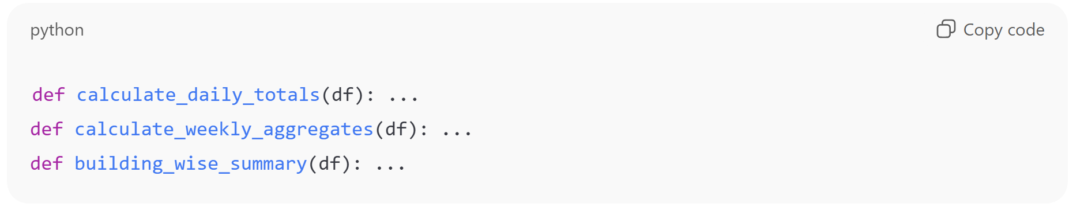

What these functions will do:
- Use groupby() and resample() to find daily and weekly totals
- Store building-wise stats like mean, min, max, total
- Prepare DataFrames and dictionaries for plotting later
Expected Output:
- Daily and weekly electricity usage
- Summary table for each building

Task 3: OOP Structure :
To make the code cleaner, I will model buildings and readings using classes.
Classes to create:
- Building
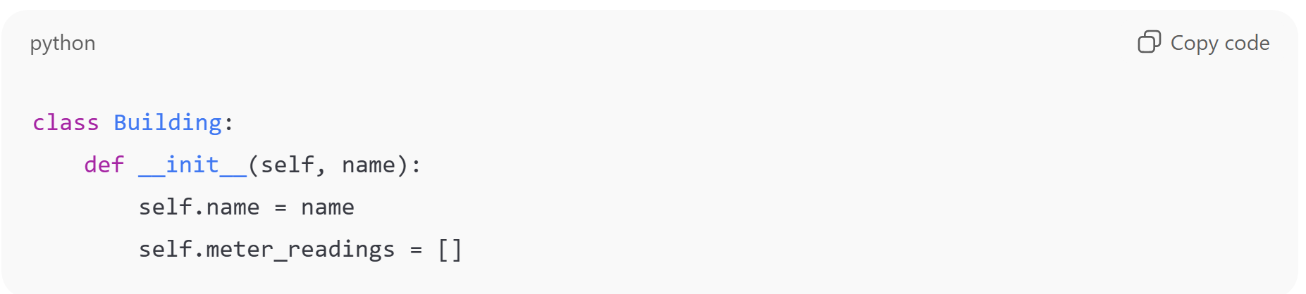

- MeterReading
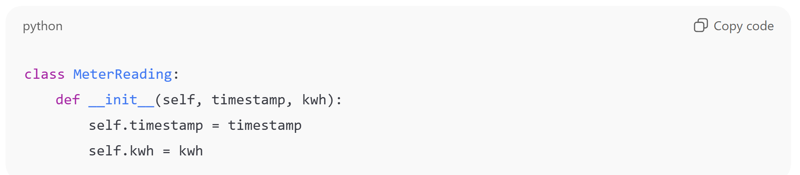

- BuildingManager
To manage multiple buildings.
Methods to add:
- add_reading()
- calculate_total_consumption()
- generate_report()
Expected Output:
Objects for each building with calculated readings and summaries.

Task 4: Dashboard Visualization :
Here I will use Matplotlib to create 3 charts and arrange them like a dashboard.
Charts to include:
- Line Chart – daily consumption trend
- Bar Chart – weekly average comparison between buildings
- Scatter Plot – peak-hour usage
I will use plt.subplots() to place them together and save the final dashboard as dashboard.png.

Task 5: Saving Results + Summary :
Finally, I have to export all my results.
Files to create:
- cleaned_energy_data.csv – final cleaned dataset
- building_summary.csv – stats for each building
- summary.txt – short written summary including:
  - total campus electricity use
  - highest consuming building
  - peak load timing
  - daily/weekly trends
I can also print this summary inside the Python script.

Submission Requirements :
I must upload everything to a GitHub repo named:
campus-energy-dashboard-<myname>
The repo must contain:
- All Python scripts / notebook
- /data/ folder with sample dataset
- dashboard.png
- All exported CSVs
- README with objective, method, and insights

Rubric (How it will be graded) :-
- Data cleaning – 20%
- Aggregations – 20%
- OOP design – 20%
- Visualizations – 20%
- Summary + exported files – 10%
- Code quality + GitHub – 10%

